Assignment No.: 11
Problem Statement:Build scaling plans in AWS that balance the load on different EC2 instances.
Step1:Login int AWS account and create a template. Select Ubuntu in quick start.
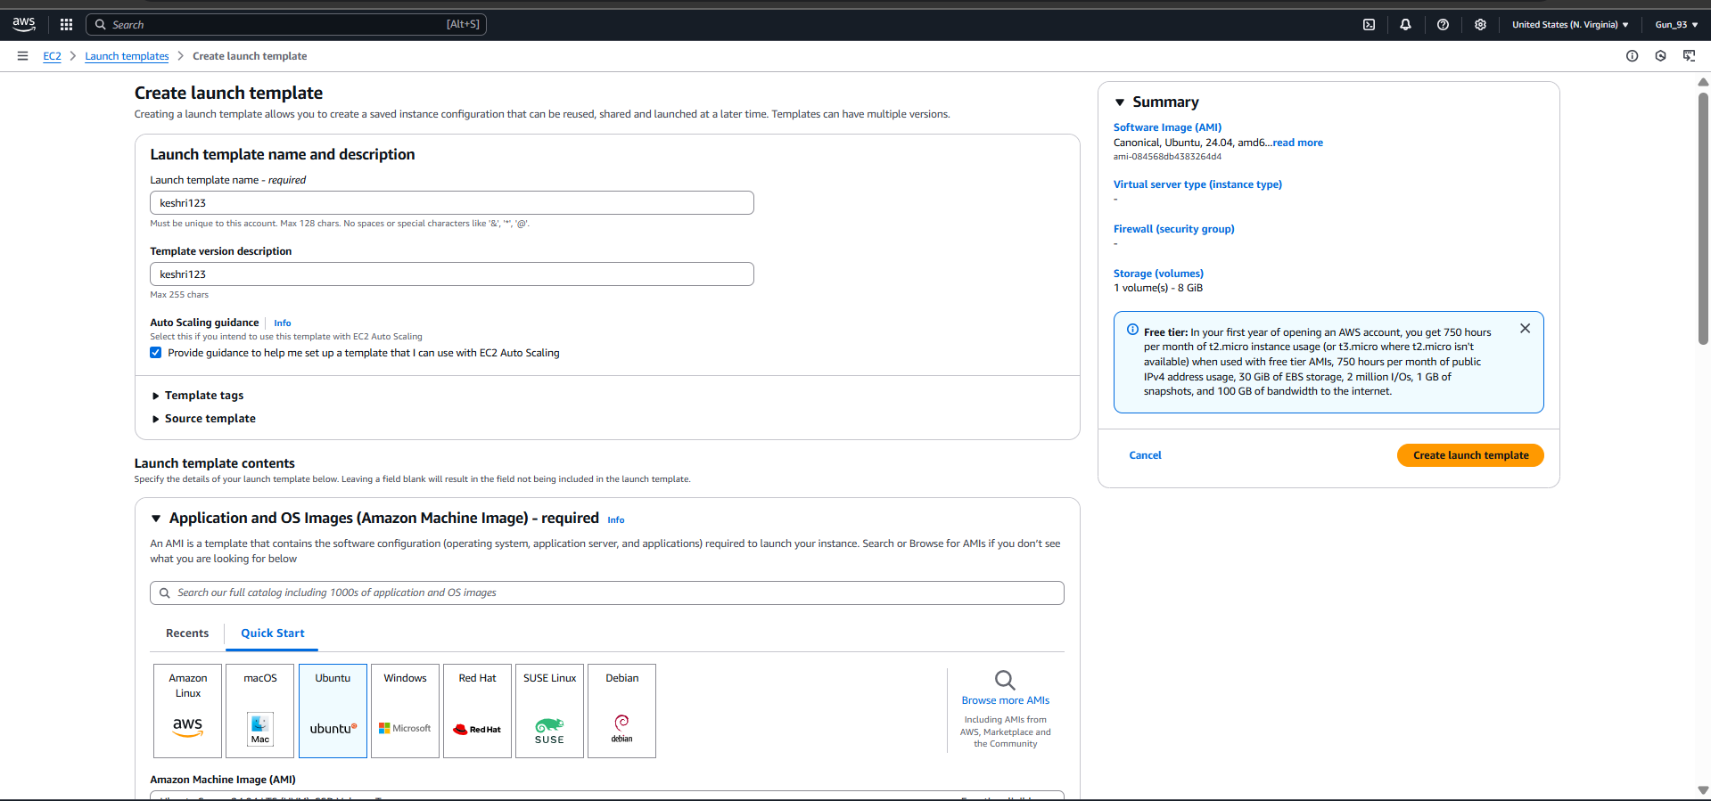
Step2:Select key pair and select existing security group in Firewall (security groups).
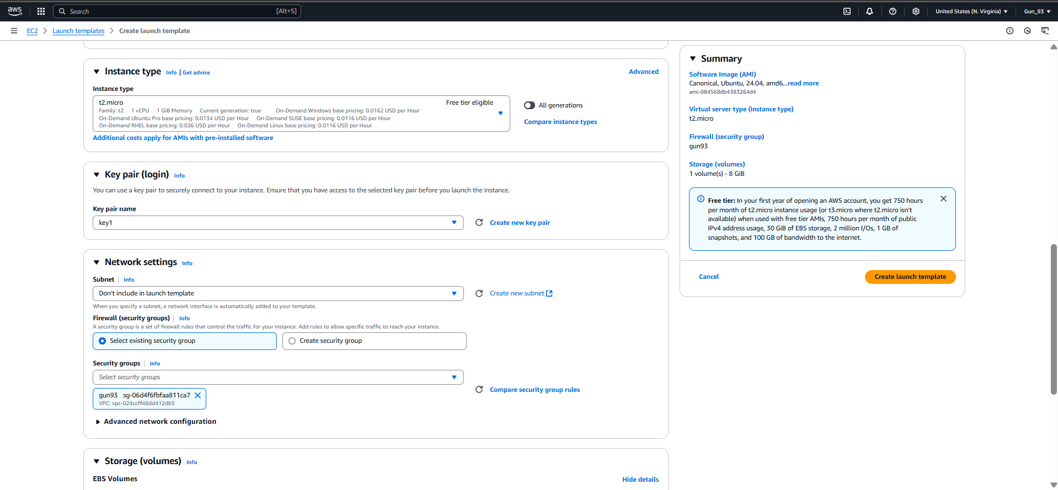
Step3:After Selecting security group go to the user data and write given cmd. Click launch instance.
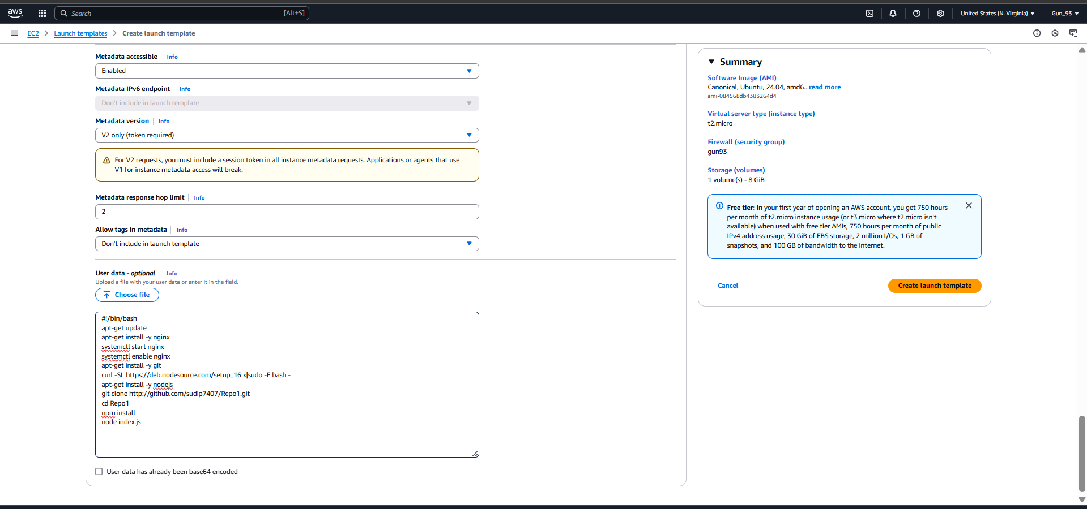
Step4:Create auto scaling group, enter name for auto scaling group, select template, click on next.
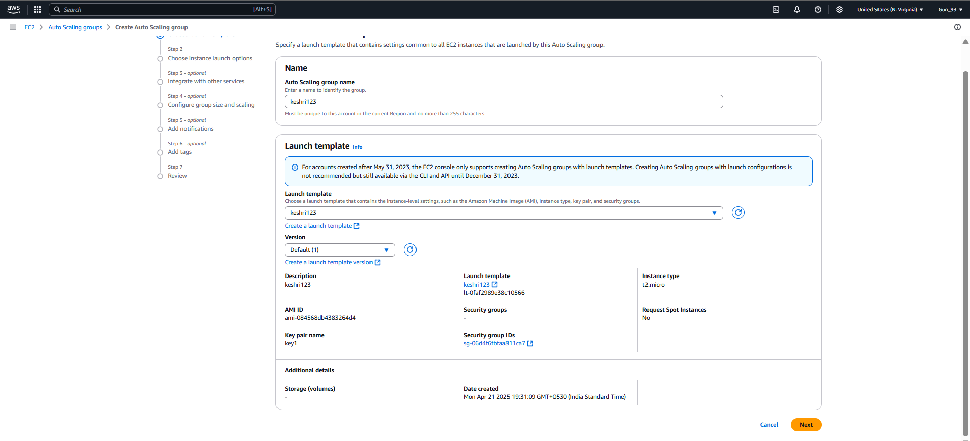
Step5:Now select all availability zones and subnets then click on next.
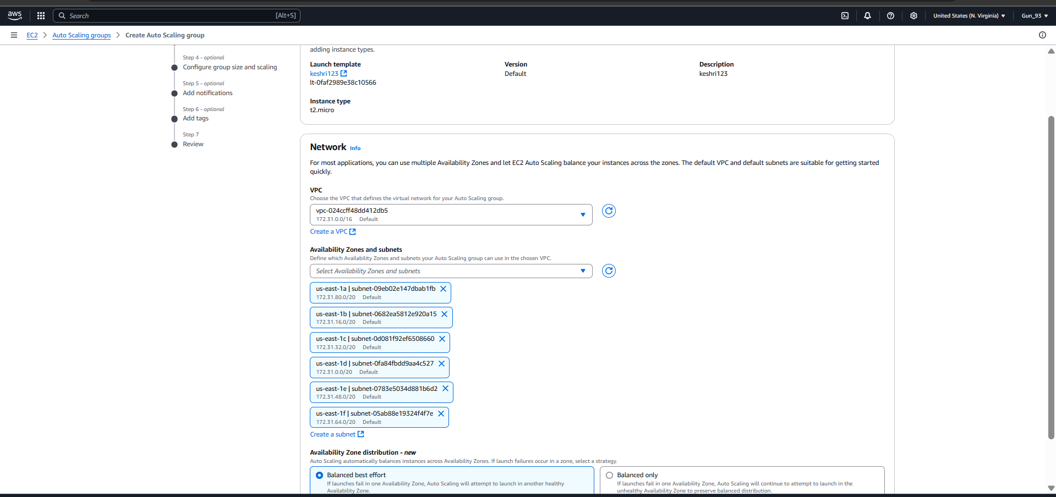
Step6:In load balancing select attach to new load balancer, in attach to new load balancer select aplicatio load balancer, in load balancer select internet-balancing.
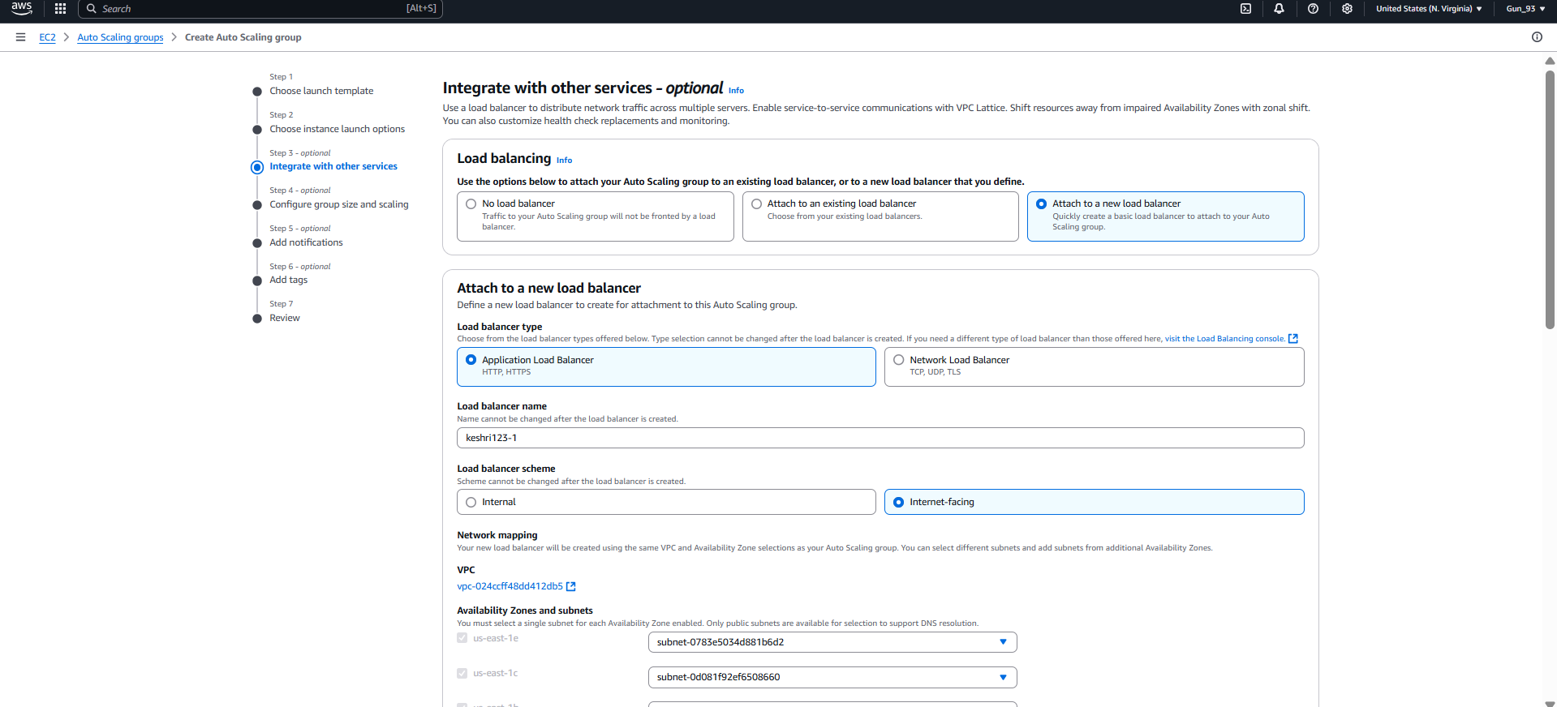
Step7:In add 1000 in port, select new target group name. In health check period add 200 seconds.
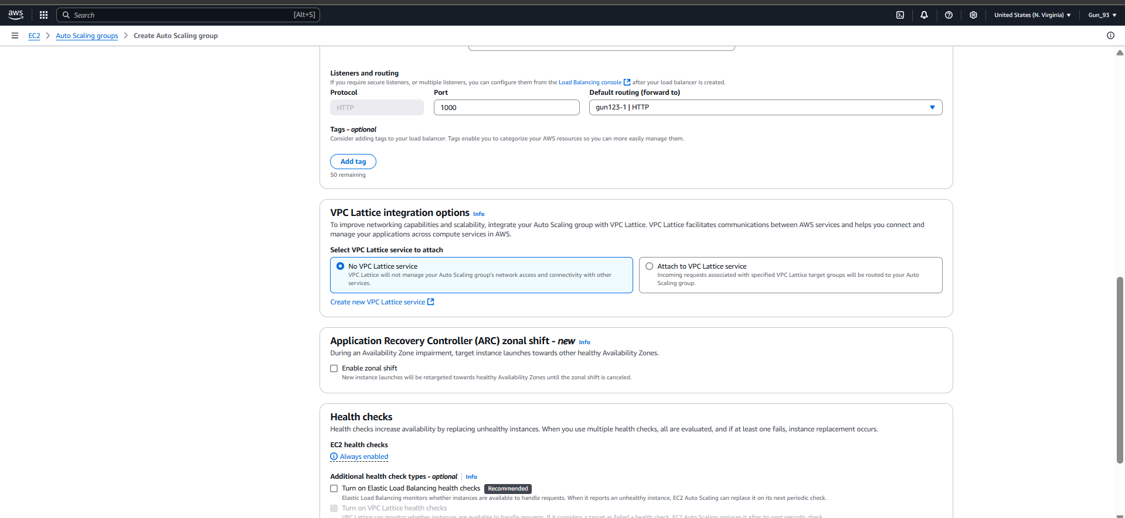
Step8:In desired capacity write 2. In scaling limit give min 2 and max 3.
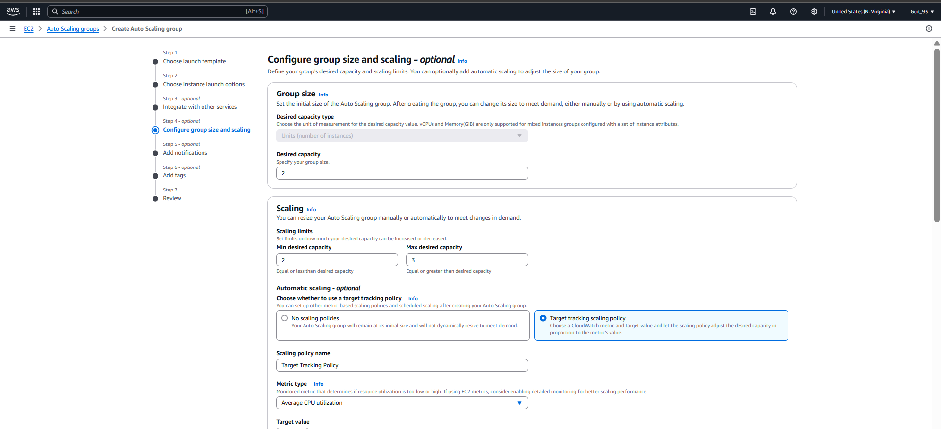
Step9:In target value as 50, instance warmup as 200 sec. Then click on create auto scaling group.
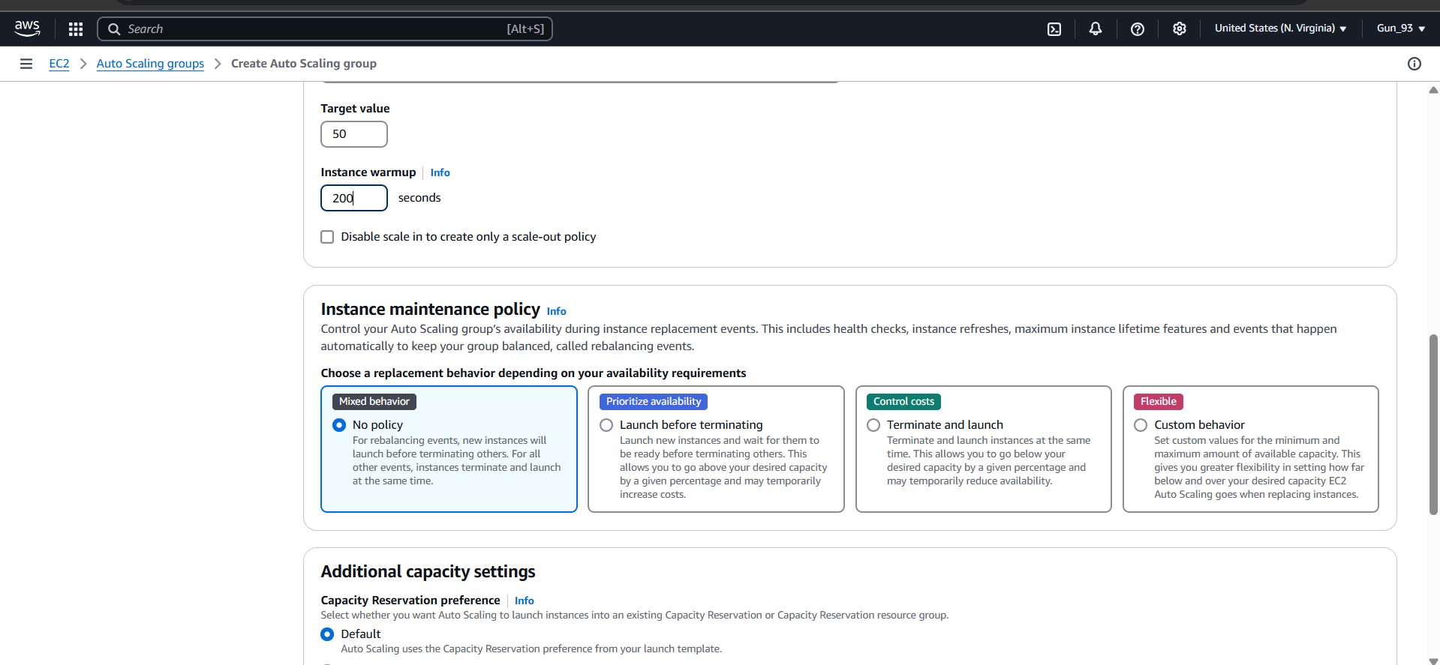
Step10:Go to load balancer copy DNS name and run it in another tab.
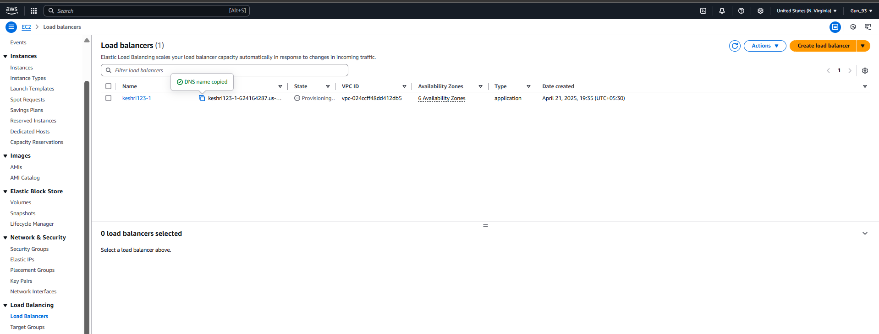

Step11:Now open bitwise and copy Public IPv4 adress from any one instance and paste it in port. Open terminal and write the given command, it will start a loop.
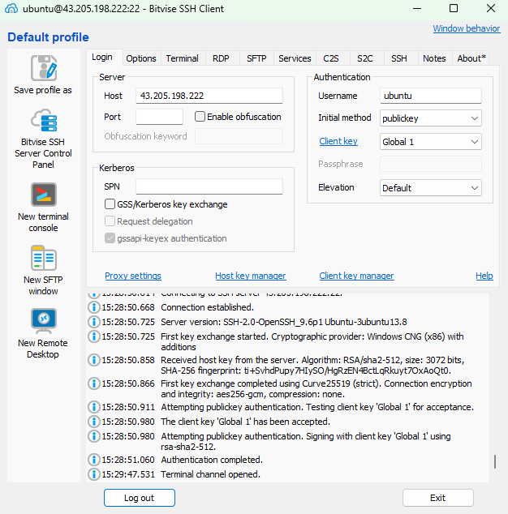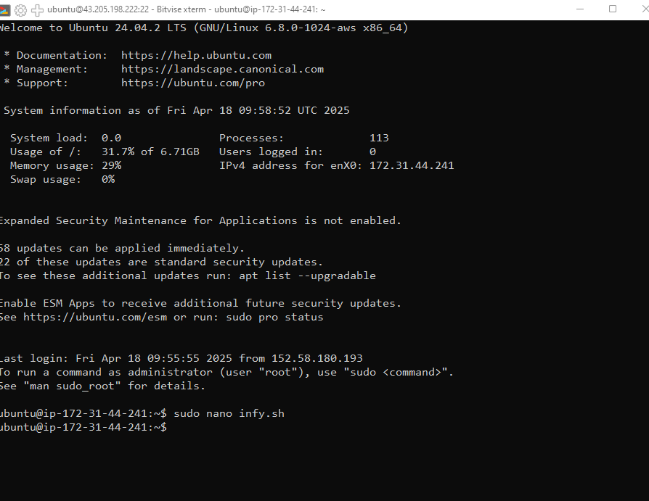
Step12:In security we can see CPU utilization graph.
